MSB1004 Modelling Biosystems;

Assignment 1

Assignment due date: 15-11-2024

Names**:**

Maaike Kessen, i6276310

Siem Vonk, i6290798

Sem Verstappen, i6294976

Mai Le, i6375777

Maastricht University

Faculty of Science and Engineering

**Table of contents**

SECTION 1 – 65 marks 2

SECTION 2 – 10 marks 12

# **SECTION 1 – 65 marks**

**1) Draw a schematic of the breast cancer growth model, with the species as nodes and the interconversions as edges. Indicate relevant parameters next to the corresponding edges (10 marks).**

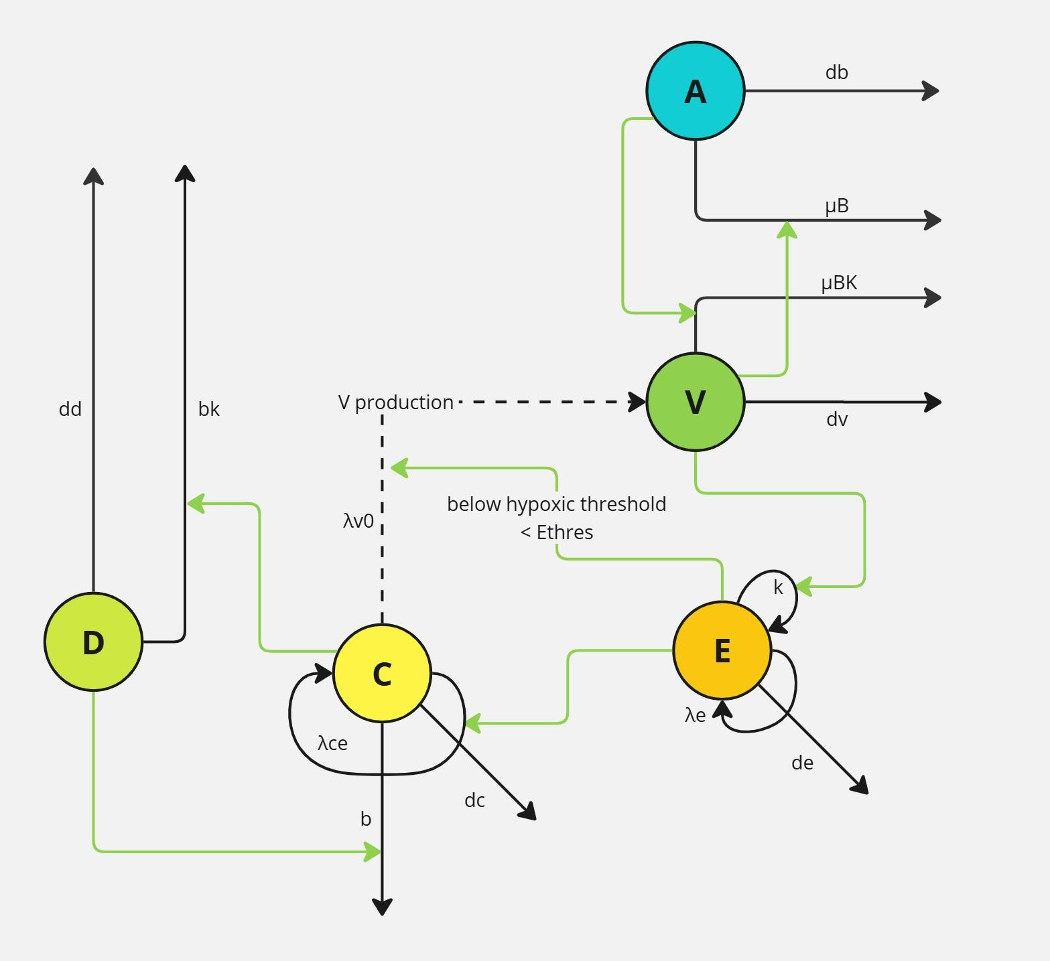

**Figure 1: The schematic of the breast cancer growth model.**

Black arrow = flow of material, Green arrow = flow of information.

D: chemotherapeutic drug, C: breast cancer cells, E: endothelial cells, V: vascular endothelial growth factor, A: anti-VEGF drug.

dd: clearance rate of the chemotherapeutic drug, bk: clearance rate of the chemotherapeutic (when binding to the cancer cells), 𝜆ce: proliferation rate of the tumor cells, b: death rate of the cancer cells due to chemotherapy, dc: natural death rate tumor cells, 𝜆e: proliferation rate endothelial cells, de: natural death rate endothelial cells, k: rate of VEGF-induced proliferation, 𝜆v0: baseline VEGF secretion by tumor cells, 𝜇Bk: clearance rate of the anti-VEGF drug (when binding to VEGF), dv: decay rate of VEGF, 𝜇B: removal of VEGF (when binding to anti-VEGF drug ), db: clearance rate of anti-VEGF drug.

**2) Write down the system of ordinary differential equations modeling breast cancer growth according to your schematic. Clearly specify which simplifications and assumptions you make and link the equations to the text given above. Note that if the order of the kinetics is not known, a general order “n” can be assumed. (20 marks)**

$\frac{dD}{dt}= - dd⋅ D - bk⋅C⋅D⋅E$

$\frac{dC}{dt}=(λce⋅E )𑁦 C 𑁦 (1 - {\frac{C}{CM}}_{}) - dc 𑁦 C - b 𑁦 D 𑁦 C⋅E$

$\frac{dV}{dt}= λv0 ⋅ C - dv ⋅ V - uB ⋅ V ⋅ A$*E < Ethres*

$\frac{dV}{dt}= -dv⋅V-uB⋅V⋅A$*E > Ethres*

$\frac{dA}{dt}= -db ⋅A-uBk⋅V⋅A$

$\frac{dE}{dt}= λe⋅E⋅(1-\frac{E}{EM})+k⋅V-de⋅E$

**Assumptions**:

**2.1: Chemotherapeutic drug at the tumor site:**

We assume that the concentration of chemotherapeutic drug that can reach the tumor site is dependent on the amount of endothelial cells as blood vessels have an endothelial lining. This can be seen in the equation for C: - $b 𑁦 D 𑁦 C⋅E$. This can also be seen in the clearance of the drug that is bound to C: $- bk⋅C⋅D⋅E$. Moreover, the concentration of chemotherapeutic drug is decreased by the natural clearance of the drug (dd) after injection. The effect of the b parameter is negligible in the current model, but this parameter can be changed with a factor of for example 50, which will show a more realistic prediction of the cancer growth if the drug would have more of an effect.

**2.2: For the tumor size**

We assume that $λ$ ce is influenced by E by multiplying it with the value of E ($λ$ ce*E). Another way of doing this is multiplying $λ$ ce with a function of endothelial cell density. But the given information is not clear enough to identify this function. The tumor size is reduced due to both natural death rate and chemotherapeutic drugs. We assume that the death rate of cancer cells caused by chemotherapeutic drug depends on the density of endothelial cells at the tumor size as the endothelial cells are stimulated by VEGF to form new blood vessels, which facilitate the drug delivery to tumor. Therefore, the term of tumor’s death rate related to chemotherapeutic drug is identified as: $- bk⋅C⋅D⋅E$.

**2.3: For the concentration of VEGF**

The VEGF concentration has another production rate when E is below the hypoxic threshold. To be more specific, when the endothelial cell density at the baseline is lower than the threshold, cancer cells will release VEGF with the rate $λv0$ to increase the production of endothelial cells. This process will stop if the endothelial cell density reaches the threshold. The concentration of VEGF is also decreased due to natural clearance and binding to anti-VEGF drugs.

**2.4: For the concentration of anti-VEGF drug**

Besides natural clearance, anti-VEGF drug is decayed by binding to the VEGF with the removal rate = $uB$.

**2.5: For the size of endothelial population**

We assume that all the VEGF reaches the endothelial cells and has an effect. In addition to logistic growth, the growth of E is directly proportional to the growth of V, indicated by $k⋅V.$

The growth of endothelial cells is reduced by the natural death rate. We can see the indirect effect of anti-VEGF drug on cancer cells through the differential equation of endothelial cells. Anti-VEGF drug will decrease the amount of VEGF, thus reducing the growth of endothelial cells and further influencing both the intrinsic growth rate of cancer cells and the death rate caused by the chemotherapeutic drug due to blood vessel formation.

**3) Implement the above model in Matlab and run the model using the representative values of parameters given in Table 1. Plot all variables individually and interpret each individual plot, e.g. explain why the time course for each variable looks as it does, including the start and end value. (15 marks)**

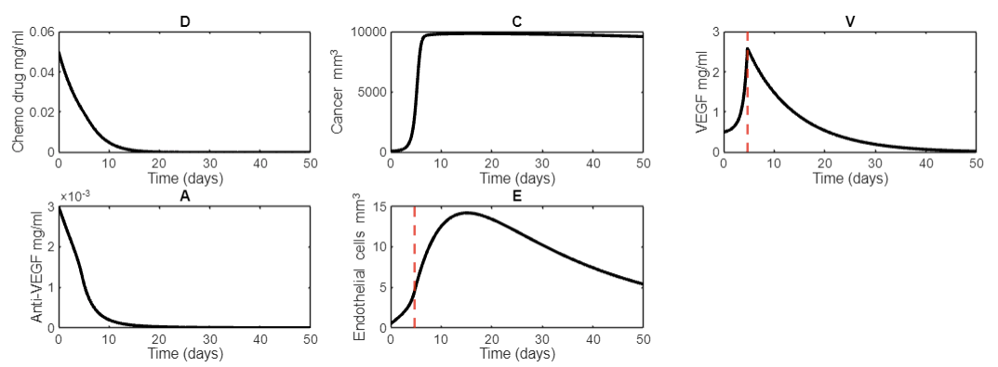

D is administered at the start, which is then degraded to 0 and logically does not increase as there is not more D administered.

C increases and then finds a steady state at Cm, which is also logical due to the logistic growth being limited by the carrying capacity. D does not seem to have a significant effect on the growth of C, only when increased to lethal doses or when the parameter b is increased in the model.

V increases when C increases because cancer cells release VEGF at the baseline when the number of endothelial cells is lower than the threshold. However, when E reaches the hypoxic threshold, the cancer cells do not secret the VEGF and $λ$ v0 is removed from the formula. Therefore, VEGF’s concentration decreases because there are only negative terms in the ODE.

A is also administered at the start and can only decrease due to clearance and removal after binding with V.

E initially increases due to the intrinsic logistic growth and the stimulation by VEGF, until it reaches the carrying capacity Em, which it cannot surpass due to the logistic growth formula. Because V is decreasing, E growth is stimulated less, and thus the negative terms will have the overhand, resulting in a decrease of E.

**4) Determine which parameters influence the tumor growth most. Explain clearly your rationale and steps undertaken, including equations and matlab implementation. Interpret your findings. (10 marks)**

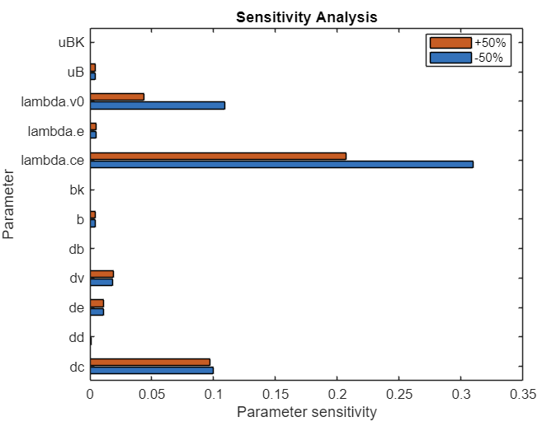

This bar chart shows the cancer volume (mm^3) at the 20th entry of the cancer output. We decided to choose the entry that is 1/5th of the total Y entries for the C value as output, because at this time the cancer cells are still growing exponentially and have not reached the maximum value yet so the parameters can influence the outcome. b does not seem to have much of an effect on the cancer growth, even when using the higher bound of the drug dosage.

From this graph, we can see that $λ$ v0 (Baseline VEGF secretion of tumor cells) and $λ$ ce (Proliferation rate of the tumor cells) causes cancer growth to respond most sensitive to a 50% increase and 50% decrease compared to the other parameters that the model contains. The natural death rate of cancer cells (dc) also seems to have relatively high parameter sensitivity.

Using matlab and the previously constructed ODEs, the sensitivity of each parameter was calculated when increasing with 50% and decreasing with 50%. The simulation was run for all parameters with the three different values. The formula for parameter sensitivity (from lecture) was then used to assess the parameter sensitivity:

parameter_sensitivity(i) = abs(((C_plus_50(i) - C_at_time_5_baseline) / C_at_time_5_baseline) * (d(i) / delta_k));

We cannot see any significant changes in the figure of C when we change the initial dose of chemotherapeutic drug (D0) or include/ or exclude the term of tumor’s death rate caused by the chemotherapeutic drug into/from the $\frac{dC}{dt}$ equation. This is due to the problem that the influence of endothelial cell density on the intrinsic growth rate of cancer cells is not clearly described. Therefore, we assume that $λ$ ce is influenced by E by multiplying it with the value of E ($λ$ ce*E). However, this intrinsic growth rate makes the cancer cells grow extremely rapidly and overshadow the small death of cancer cells due to natural death and chemotherapeutic drugs. Furthermore, the effect of the b parameter is small, as can be seen in the sensitivity analysis.

The cancer volume is still reduced by the natural death rate and the chemotherapeutic drug, but they are too small when compared to the huge proliferation of cancer cells in our models. It could be that our interpretation of the descriptive text is wrong due to a lack of information about how E density impacts on the intrinsic growth rate of C. Hence, the biological knowledge and precise relationship between endothelial cell and cancer cell are very important in this case to effectively model the effect of strategy combining chemotherapeutic drug and anti-VEGF drug in treating breast cancer cells.

Interestingly, when decreasing the intrinsic growth rate and thus the effect of $λ$ ce, the natural death rate starts getting the overhand and the effect of b still stays small.

**5) Define a research question and investigate it using the above mathematical model of cancer growth. Explain clearly your rationale and steps undertaken, including equations and matlab implementation. Interpret your findings. (10 marks)**

**Research question:** Is it more effective to administer chemotherapeutic drug at a constant rate compared to administering a loading dose only once?

To answer this question, we changed the ODE for D to 0, as we assume that therapeutically, the dose will be administered taking the clearance into account to result in a steady state of drug concentration.

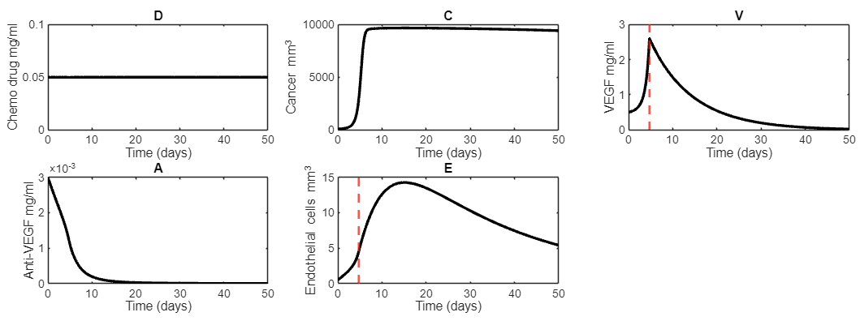

As can be seen, there is no difference for the drug effect compared to a single dose administration.

This is due to this part of the C ODE: $- b 𑁦 D 𑁦 C⋅E$ having little to no effect in the current model when compared to the growth rate $(λce⋅E )$ of the cancer cells. We can multiply this with a factor 100. This will result in a larger effect of the drug:

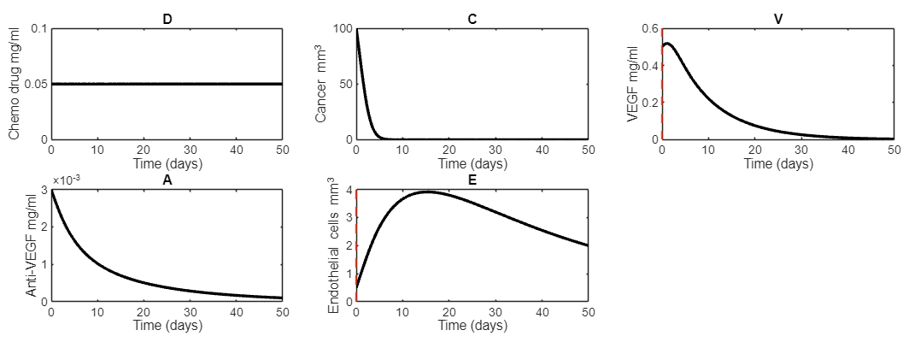

As can be seen, the cancer cells are effectively eradicated and the hypoxic threshold of E is not even reached due to little production of V by C.

When doing the same to the single dose administration, these are the produced graphs:

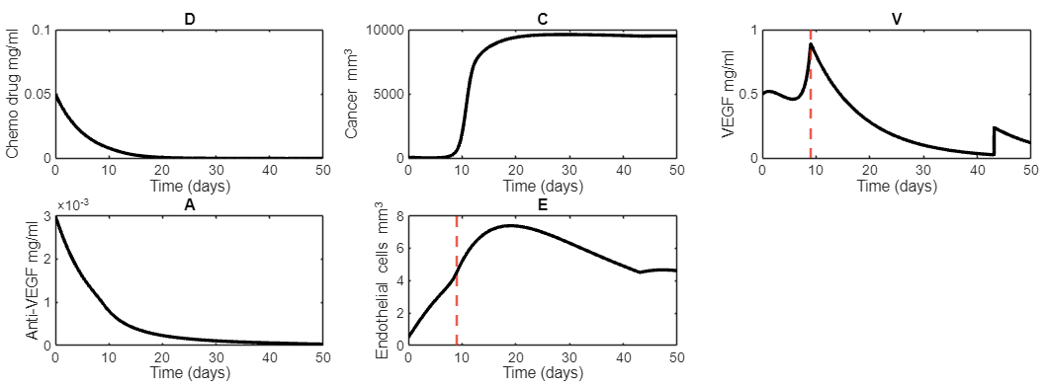

When looking at the graph of C, it can be seen that the steady state of D has a larger effect on containing the tumor growth. When administering the drug one time, the tumor eventually reaches the carrying capacity, but at a later point now that the drug effect is amplified with a factor 100. When administered at a constant rate, the tumor growth is consistently suppressed in the simulated timeframe. In conclusion, administered chemotherapeutic drug at a constant rate for a steady state concentration is more effective for cancer treatment than a single loading dose.

We tested the different drug administrations by commenting out either one of these ODE’s

dx(1) = - dd*D - bk*C*D*E; %D single dose

%dx(1) = 0; %D steady administration

Multiplying the effect of the drug by 50 instead of 100 yields the following graphs:

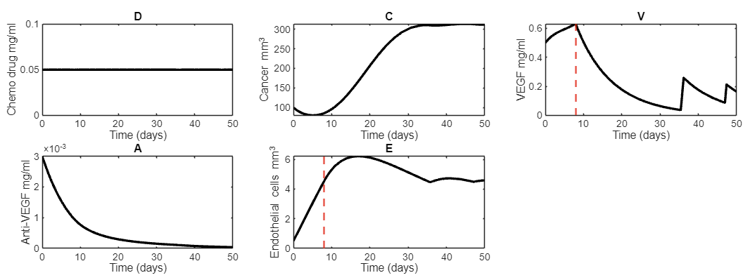

For a steady administration rate.

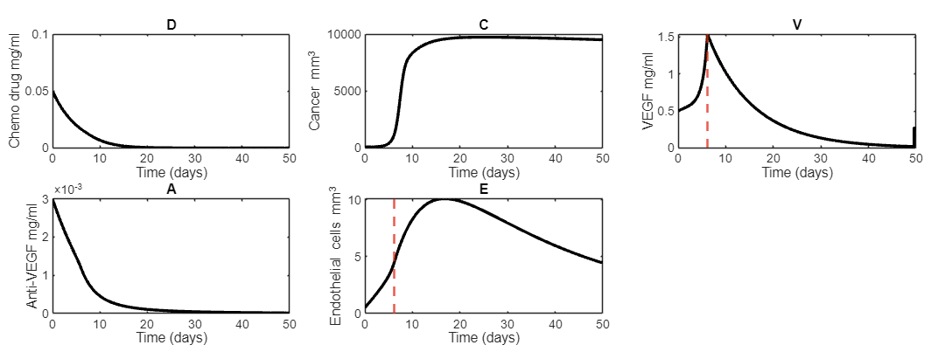

For a single dose at the start.

As expected, the sensitivity analysis then shows most variables to have insignificant effects. The drug is able to override most effects of the system and fight the cancer. The biggest effects are the intrinsic growth rate ($λ$ ce) against the death rate caused by the drug (b). These two parameters are competing on the influence of cancer volume.

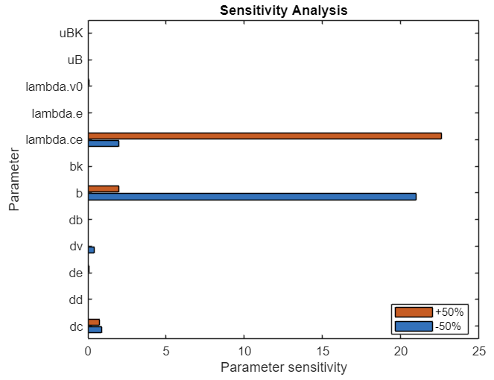

This graph shows the parameters sensitivity when $b 𑁦 D 𑁦 C⋅E$ is multiplied with 50 at a steady drug administration rate.

.

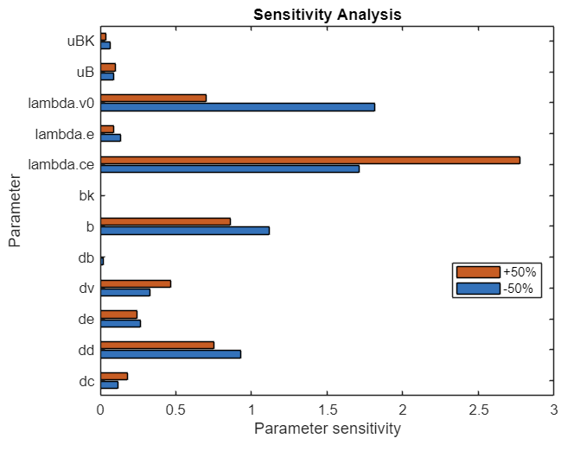

This graph shows the parameters sensitivity when $b 𑁦 D 𑁦 C⋅E$ is multiplied with 50 at a single drug administration dosage at the start.

# **SECTION 2 – 10 marks**

**a) Make a proposal for the boundary and initial conditions of the endothelial cell density in such a partial differential equation model. Mention the type of boundary condition on each of the boundaries. Make a drawing to enhance your explanation (including e.g. arrows). (2 marks)**

**Blood vessels inside tumor**

Boundary for blood vessel growth at the outer rim:

Neumann: dBV/dt = **e2**. With **e2** being a positive number

The flux(J) = **e2**

Initial condition: homogeneous distribution of 0 mm^3

**Endothelial cells in surrounding tissue**

Boundary for endothelial cell growth at the outer rim:

Neumann: dE/dt = 0

In the figure: e2 - e1 = 0

The flux(J) = 0

Initial condition: homogeneous distribution of 3 mm^3 (according to the table 1)

For example, e2 and e1 could be 0.1 mm^3/day

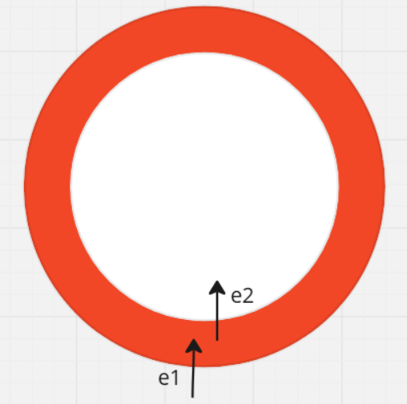

**b) Make a drawing of the vascular endothelial growth factor distribution in the tumor, considering a very low and very high diffusion coefficient. Explain the reasoning behind your drawing. (4 marks)**

Blood vessels will grow from the outside of the tumor into the middle of the tumor with diffusion like movement. Thus, the anti-VEGF is able to reach the outside of the tumor more than the middle. VEGF is secreted by cancer cells in white, VEGF will therefore be in higher concentrations in the middle compared to the outside of the tumor as the anti-VEGF can remove more VEGF on the outside.



High diffusion coefficient



Low diffusion coefficient

Blue = VEGF

**c) Make a drawing of the tumor cell density distribution in the modelled domain. Explain the reasoning behind your drawing. (4 marks)**



Black = tumor

As for the anti-VEGF, the chemotherapeutic drug also reaches the tumor through the blood vessels. The blood vessels grow from the outer rim so more drug will reach the tumor cells on the outside, creating a gradient with more tumor cells in the middle where blood vessels do not reach.

In case the chemotherapeutic drug and anti-VEGF drug cannot reduce the growth rate of cancer cells, tumor size still increases due to logistic growth. The area with the highest proliferation rate of tumor tissue is the periphery, whereas the center of the tumor has a lower proliferation rate due to limited nutrients and oxygen which lead to the necrosis core of cell death. Therefore, the density of tumor cells in this case is higher in the edge and lower in the center if not sufficiently inhibited by drugs, which is in contrast to the previously illustrated circumstance when drugs can effectively inhibit cancer development.